**ASSIGNMENT – 2.2**

**Subject: CSW2 (CSE 2141)**

**Name: Arpit Kumar Mohanty**

**Registration Number: 2341013237**

**Section: 23412G1**

**Branch: CSE**

**Q1. Create a generic class Pair with private member variables key and value. The class should include a parameterized constructor and provide getter and setter methods for these attributes. In the main class, create and add objects of the Pair class, then retrieve and print the key-value pairs.**

**Solution along with Output:**

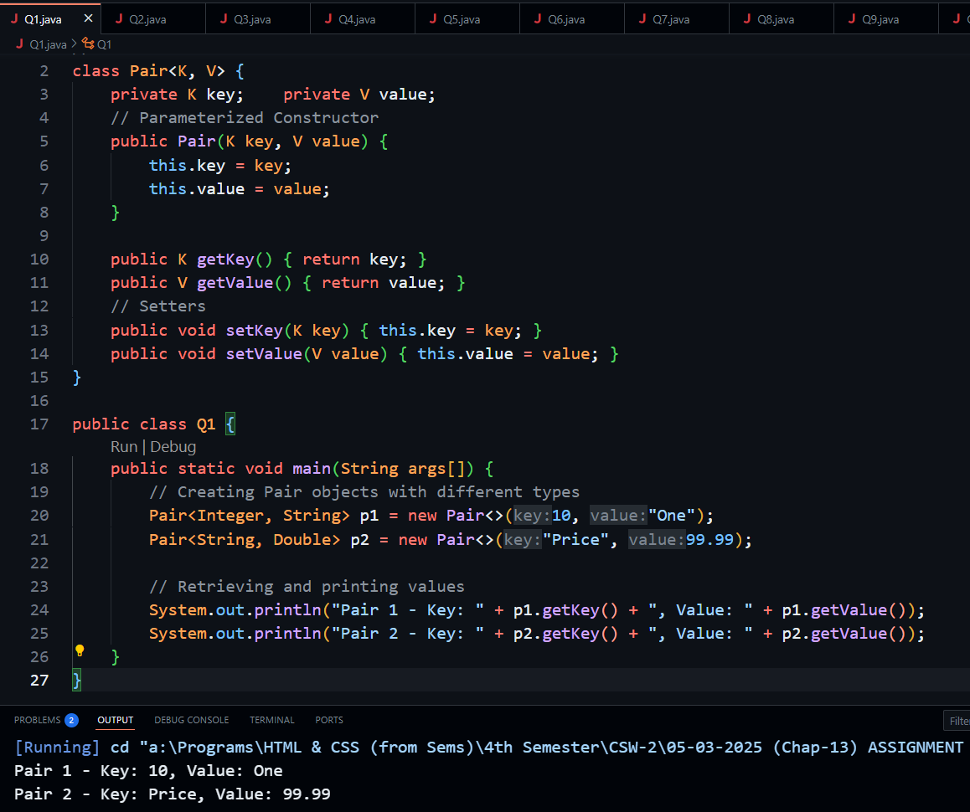

**Q2. Write a Java program that includes a User class and an ArrayListUser class. The User class should have private fields for name and age, along with a parameterized constructor and getter/setter methods for these attributes. The ArrayListUser class should create an ArrayList of User objects. After adding user objects, it should retrieve and print their name and age. Additionally, the program should sort the users based on age and print the updated list of users using getter methods.**

**Solution:**

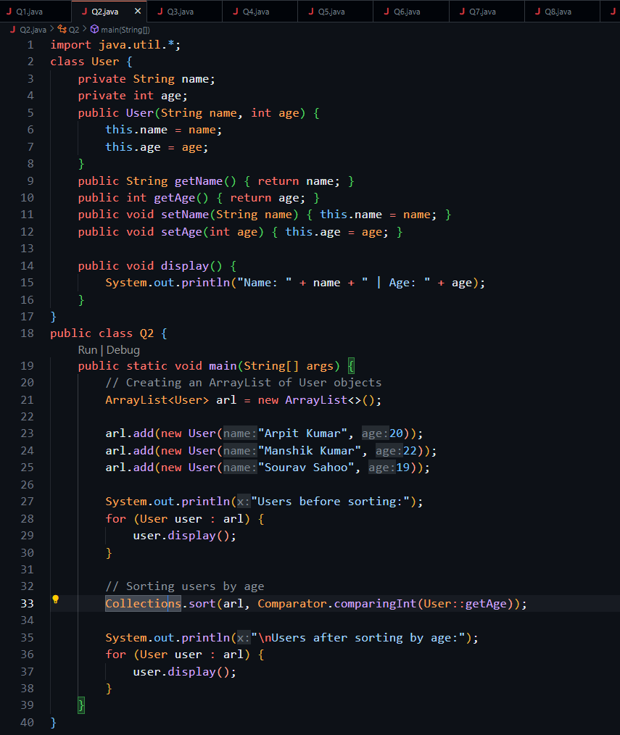

**Output: 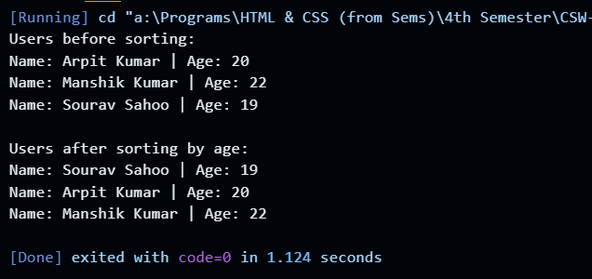  
  
Q3. Write a Java program that includes a Car class and a CarApp class. The Car class should have private fields: modelNo (int), name (String), and stock (int). Define a parameterized constructor and override the compareTo method as public int compareTo(Car car) to enable sorting of cars based on the total stock available. In the CarApp class, create an ArrayList of Car objects, sort them, and print the updated sorted list. Example of a sorted list of Car objects:**

**2013 Creta 10**

**2020 MG 13**

**2018 Kia 20**

**2017 Audi 45**

**2015 BMW 55**

**Solution along with Output:**

**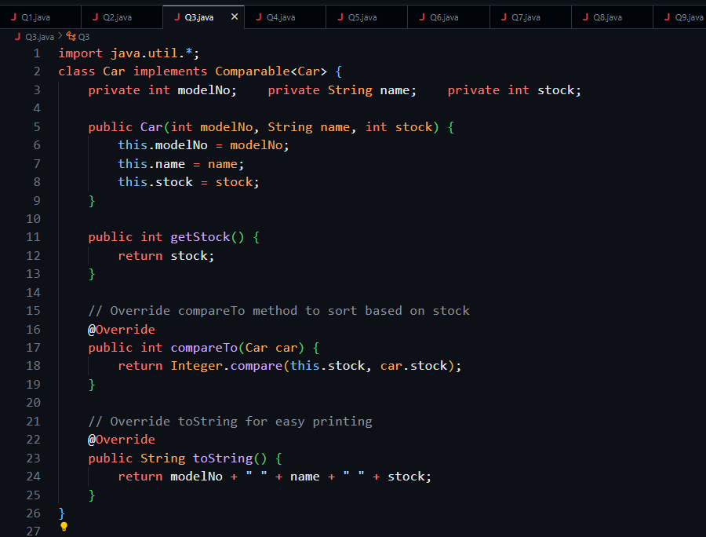  
  
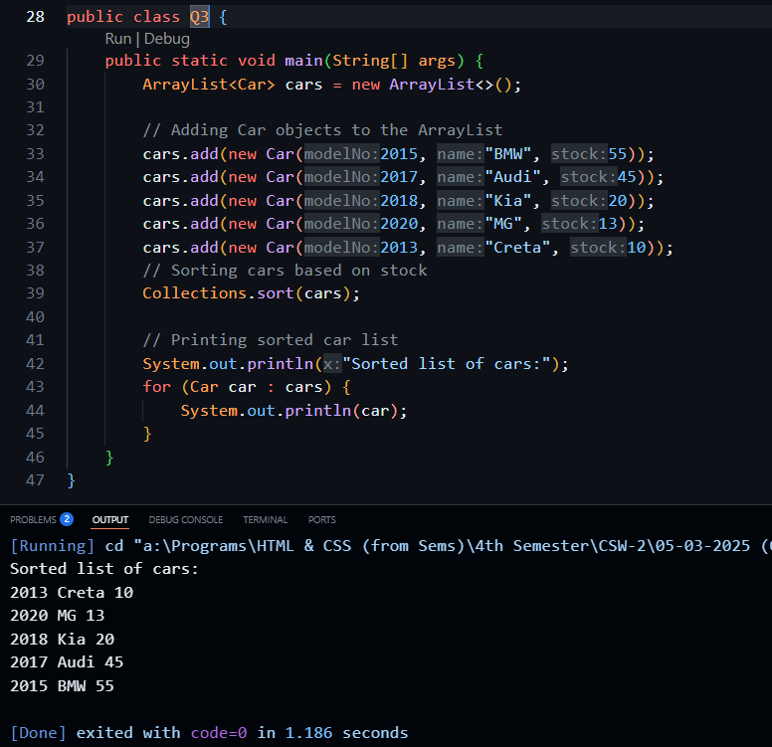**

**Q4. Create a Student class with member variables name, age, and mark, along with the necessary getter and setter methods. Implement a LinkedList of Student objects and perform the following operations: (a) Display the list of students. (b) Prompt the user to enter a Student object and check its existence in the list. Specify whether the search is based on reference comparison or content comparison using the contains method. (c) Remove a specified Student object from the list. (d) Count the number of Student objects present in the list. (e) Override the equals method to compare two Student objects based on their values rather than references**

**Solution along with Output:** 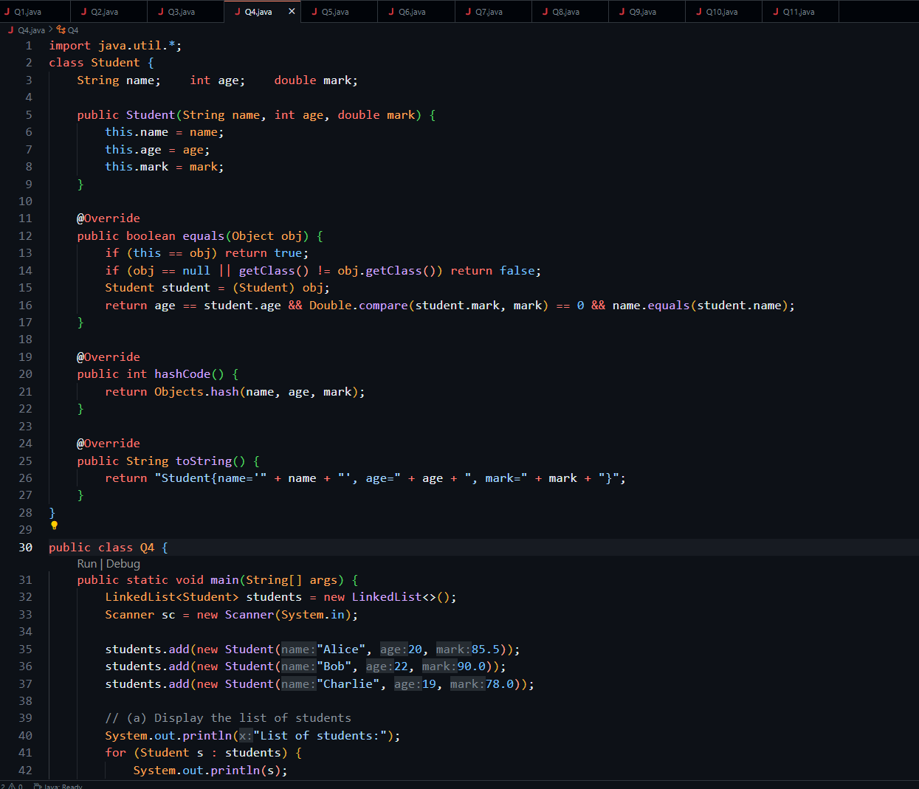

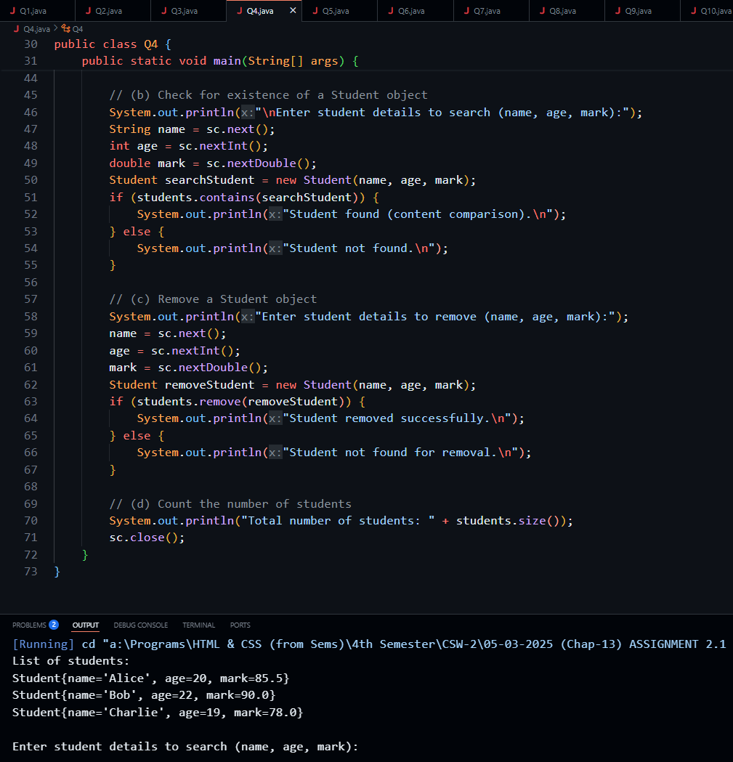

**Q5. Create a Book class with member variables id, name, author, and quantity to store details of each issued book. The Book class should include a parameterized constructor. Design a Library class that creates a HashMap of books, where the key is an Integer (representing the book ID) and the value is a Book object. Instantiate at least two Book objects and display the collection of books stored in the HashMap. Use appropriate methods of the HashMap class to perform the following operations: (a) Check if a particular book name is present on the map. (b) Remove a book entry by deleting the value associated with a specific key.  
  
Solution: 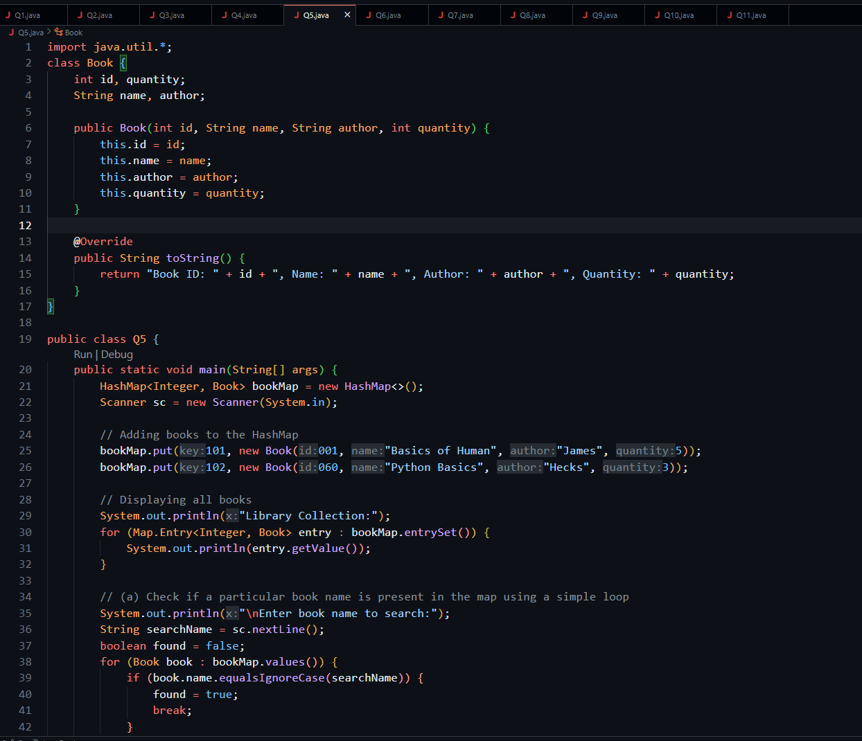  
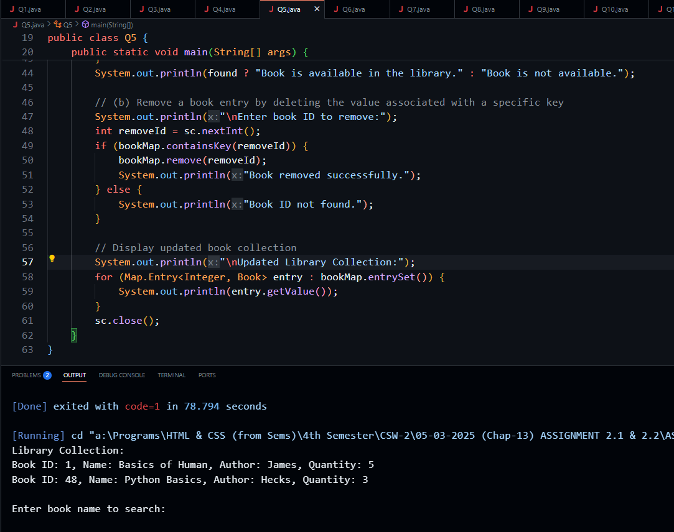**

**Q6. Write a program to create a TreeSet of Integer type and perform the following operations: (a) Display the elements of the TreeSet. (b) Prompt the user to enter a number and check whether the number is present in the TreeSet. (c) Remove a specified element from the TreeSet**

**Solution: 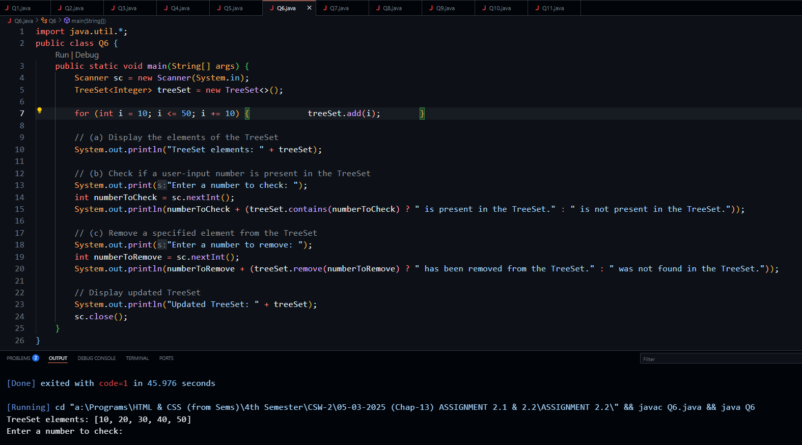  
  
Q7. Write a Java program that includes a class Address with member variables plotNo, at, and post. The class should define a parameterized constructor to initialize these attributes. Create a TreeMap, where the key is the name of a person (String), and the value is an Address object. Insert the required key-value pairs into the TreeMap and use an Iterator to display the entries.**

**Solution:** 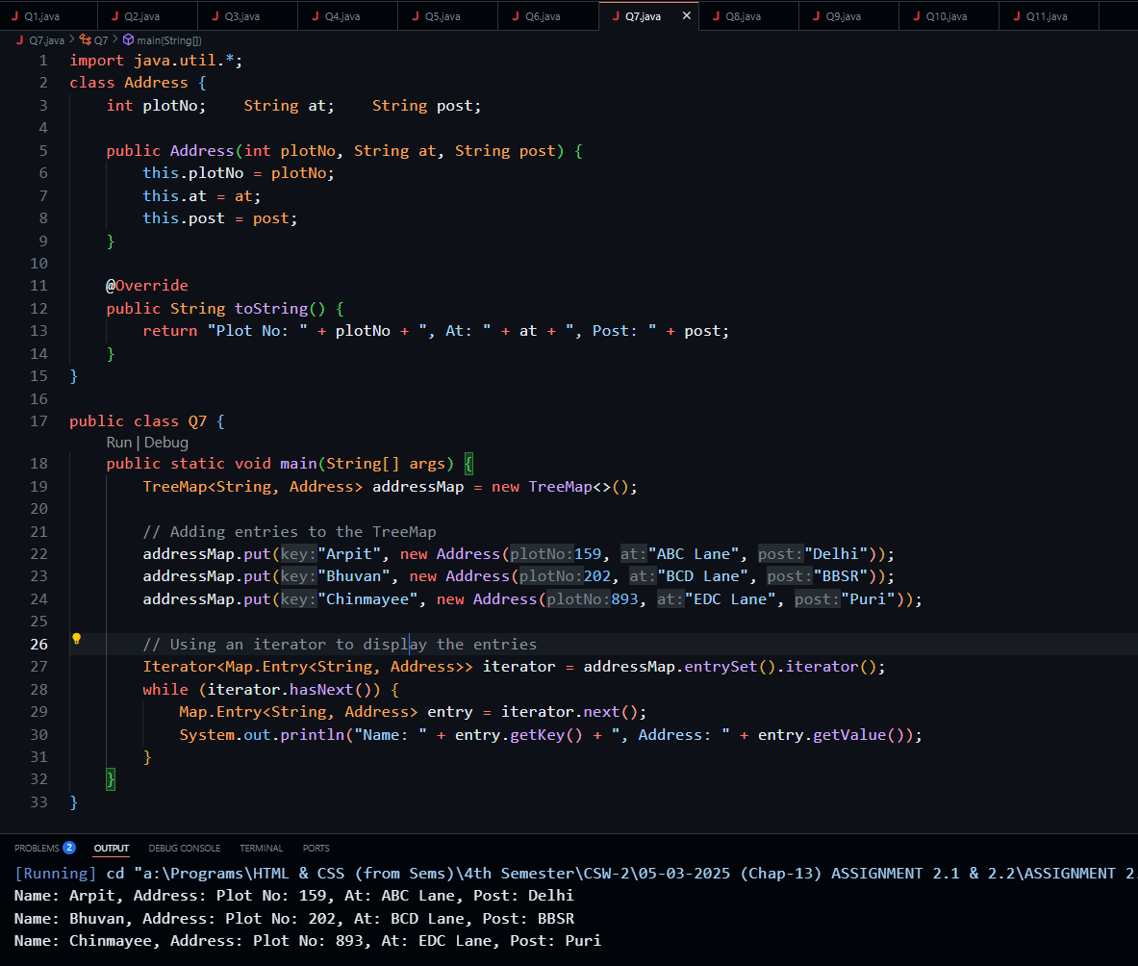

**Q8. Write a Java program to determine whether two given strings are anagrams. An anagram is a word or phrase formed by rearranging the letters of another word or phrase. Declare two strings, str1 and str2, and initialize them with values. Create a HashMap to store the character frequencies of one string. Use the methods containsKey(), put(), and get() to compare both strings and verify if they are anagrams.**

**Solution: 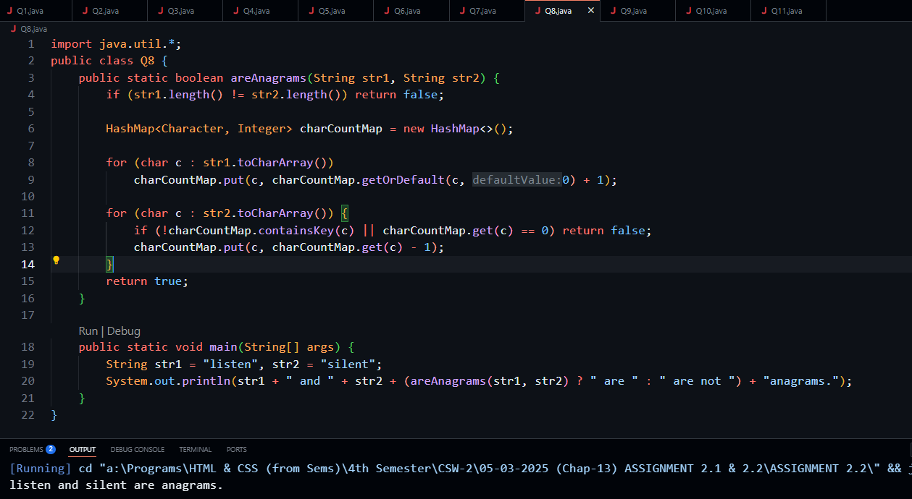  
  
Q9. Given an array of integers, write a Java program to identify and print the repeating integers using a HashSet.  
  
Solution:** 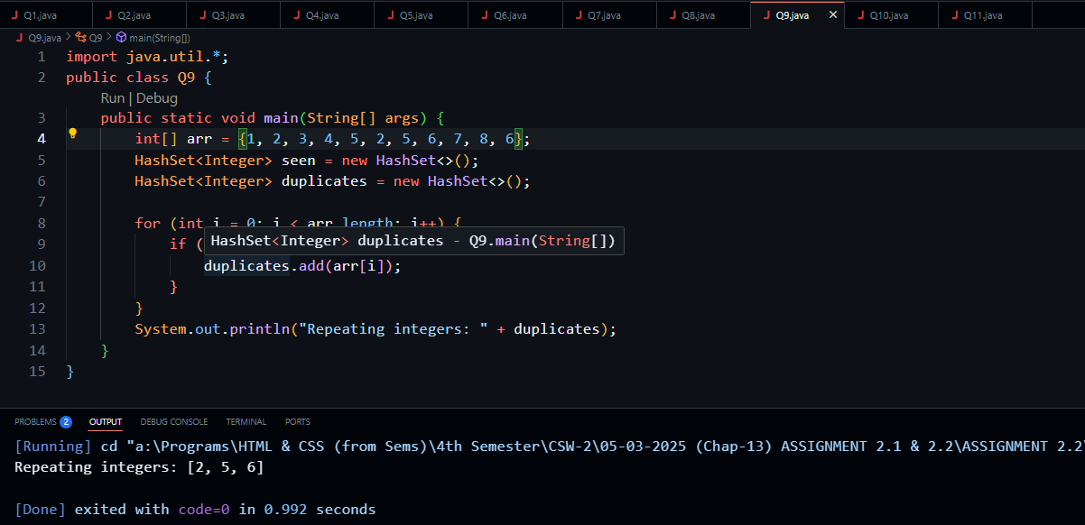

**Q10. Given an unsorted array of integers ranging from 1 to 10, write a program to find the smallest positive number missing in the array. Use a HashMap to keep track of the elements and identify the missing number.**

**Solution:**

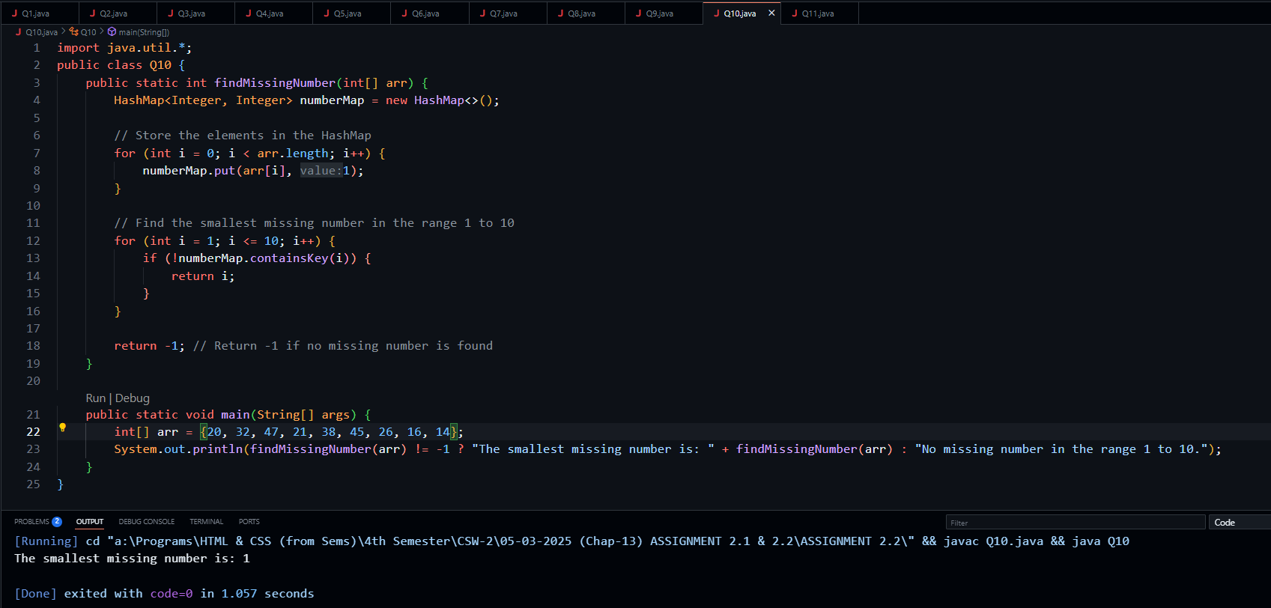

**Q11. Declare an array of integers: int[] arr = {1, 2, 10, 8, 7, 3, 4, 6, 5, 9};. Then, create a min-heap using the PriorityQueue class to store the elements from the array. Finally, dequeue the elements from the PriorityQueue using the appropriate methods and print them**

**Solution:** 